Certificate
Department of Computer Science and Engineering

This is to certify that this Practical Record contains the bona fide practical work carried out by Mr./Ms. ______________________________________________, bearing PRN. _____________________, of Batch _________, Semester ______, Section _________, during the Academic Year __________________.

Date: _____________

Name of Course Teacher: _________________________________________

Signature of Course Teacher: ______________________________________

Name of Student: ________________________ PRN: _________________
Batch: ______________ Semester: ____________ Section: ______________
Index
Practical No. | Aim | Performance Date | Submission Date | Remarks
1 | Demonstrate inline, internal, and external JavaScript; use console methods; create a webpage showing user info and a welcome message.
2 | Use var, let, const, and demonstrate basic features like template literals and destructuring; build a billing calculator with user input.
3 | Implement control structures and form validation; create a grading system based on user-entered marks.
4 | Use function types, scope, and closures; apply try-catch; build a palindrome checker.
5 | Apply array methods and object handling; create a cart total calculator with discount logic.
6 | Use string functions and regex for email validation, data extraction, and text analysis.
7 | Perform DOM traversal and updates; develop a to-do list app with add, edit, and delete features.
8 | Access and validate form fields using events; design a gym admission form with live input checks.
9 | Implement localStorage and sessionStorage to save user preferences like theme settings.
10 | Load and display JSON data using fetch() and jQuery $.getJSON(); render results dynamically in a table.
VA 11 | Use JavaScript timers (setTimeout(), setInterval()) and ES6 modules (import/export) to build a dynamic countdown or class scheduler with real-time updates and responsive layout.
VA 12 | Build an interactive real-time web app using JavaScript and jQuery with DOM, events, storage, and AJAX integration.

Experiment No.:1
1. Title: Demonstrate inline, internal, and external JavaScript; use console methods; create a webpage showing user info and a welcome message.
2. Software/Tools Required:
- Visual Studio Code (VS Code)
- Google Chrome
- HTML5
- JavaScript
3. Theory: JavaScript is a client-side scripting language used to make web pages interactive and dynamic. It can be included in an HTML document in three ways:
- Inline JavaScript: JavaScript code is written directly inside an HTML element using event attributes like onclick.
- Internal JavaScript: JavaScript code is written inside the <script> tag within the HTML document.
In this experiment, Internal CSS is used to style the webpage with colorful headings, centered text, and a styled button. JavaScript is used to display a welcome message, show an alert on button click, and demonstrate console methods such as console.log(), console.info(), console.warn(), and console.error() for debugging.

4. Output:
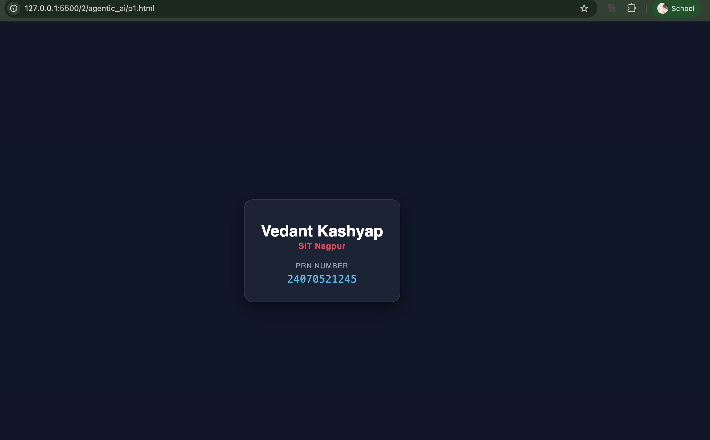

5. Result/Conclusion:
The experiment was successfully performed. The webpage correctly demonstrated the use of Inline, Internal, and External JavaScript, displayed the user information and welcome message, and used Internal CSS for styling. JavaScript console methods executed successfully, and the alert message appeared when the button was clicked. The objectives of the experiment were achieved successfully.

